QE 2017 Semiconductors: Optoelectronics (40 pts)

1. Consider a three-layer dielectric slab waveguide, consisting of a high index (n_{H}) core and two low-index (n_{L}) cladding layers. Discuss the difference between guided and radiation modes in the dielectric waveguide using ray optics. [10 pt]

2. An electron with mass is confined in an infinite quantum well (QW) (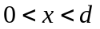).
a) Find the energy level 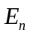 and wave function 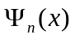 (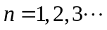). [10 pt]
b) According to the selection rule, the electron transition between two states cannot occur if the wave functions 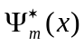 and are orthogonal to each other,
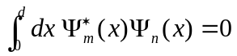.
Find the longest emission (or absorption) wavelength of the infinite QW. [10 pt]

3. A semiconductor laser has a Fabry-Perot cavity where the cavity length is , the mirror reflectivities are and , and the internal loss is . Find the threshold gain of the semiconductor laser. [10 pt]

